AD23421 / INTERNSHIP

REGULATIONS – 2023

B. TECH
II YEAR – IV SEMESTER ACADEMIC YEAR: 2025 – 2026 (EVEN)



DEPARTMENT OF ARTIFICIAL INTELLIGENCE AND DATA SCIENCE

Rajalakshmi Engineering College Thandalam, Chennai-602105


Rajalakshmi Engineering College Thandalam, Chennai.

Cover Letter

Registration Number : 2116241801290 Student Name : Tarika A G
Year / Semester : II / IV
Department : Artificial Intelligence and Data Science Email ID : tarika.ag.2024.aids@rajalakshmi.edu.in
Phone Number : 8807807801

Date:

Subject: Application for Internship Opportunity in Your Organization

Respected Sir/Madam,
I am a student pursuing B.Tech in Artificial Intelligence and Data Science at Rajalakshmi Engineering College, Chennai, and I am writing to apply for an internship in your esteemed organization. I am eager to gain practical experience and apply my academic knowledge to real-world problems in software and technology development.
I am passionate about learning new technologies, working in a team environment, and contributing to the development of recent software and innovative solutions. I believe this internship will help me enhance my technical and analytical skills while supporting your organization’s goals.
Thank you for your time and consideration.

Yours sincerely,


Rajalakshmi Engineering College Thandalam, Chennai.

DEPARTMENT OF ARTIFICIAL INTELLIGENCE AND DATA SCIENCE

Recommendation Letter for Internship

,

This is to certify that Mr./Ms. Tarika A G, a student of B.Tech in Artificial Intelligence and Data Science, Semester IV , Year II, at Rajalakshmi Engineering College, Chennai, for the Academic Year 2025-2026, is recommended for an ☐ Online / ☐ Offline internship program in your esteemed organization.
Tarika A G has been a responsible and disciplined student during their time at our institution. We believe they will benefit from and positively contribute to the internship program.
We strongly recommend Tarika A G for the Online / Offline internship program and wish them success in all future endeavors.

Sincerely,
Dr. J M Gnanasekar Professor & Head,
Department of Artificial Intelligence and Data Science, Rajalakshmi Engineering College (Autonomous), Thandalam - 602 105, Chennai.
hod.aids@rajalakshmi.edu.in.
Date:


Rajalakshmi Engineering College Thandalam, Chennai.

DEPARTMENT OF ARTIFICIAL INTELLIGENCE AND DATA SCIENCE

DATA SCIENCE

AD23421 – INTERNSHIP
Internship Report submitted by

REGISTRATION NUMBER : 241801290
STUDENT NAME : TARIKA A G
YEAR / SEMESTER : II / IV

INTERNSHIP ORGANIZATION
/ COMPANY

: ALTRUISTRY INNOVATION PVT LTD

ONLINE / OFFLINE : ONLINE

TRAINER NAME : PAMAJULA PRAVALIKA

INTERNSHIP PERIOD : FROM : 16/12/2025 TO: 31/12/2025 INTERNSHIP DURATION : DAYS 15

(Approved / Not Approved)

FACULTY ADVISOR
(Approved / Not Approved)

EXAMINER 1
(Approved / Not Approved)

EXAMINER 2
(Approved / Not Approved)
HoD / AIDS

INDEX

S.No | Table of Contents | Page Number
1 | Abstract / Executive Summary | 1
2 | Introduction | 2
3 | Objectives of the Internship | 3
4 | Brief Description of Work / Project | 4
5 | Learning Outcome | 15
6 | Conclusion | 16
7 | Internship Completion Certificate | 17
8 | Internship Feedback | 18

Abstract / Executive Summary

The main objective of the internship was to develop a Customer Churn Analytics Dashboard to analyze telecom customer data and identify factors contributing to customer attrition.
The project involved data preprocessing, exploratory data analysis, and implementation of a machine learning classification model to predict customer churn. Key features such as tenure, contract type, monthly charges, and internet services were analyzed to understand churn patterns. The insights were presented through an interactive dashboard displaying important metrics such as churn rate, revenue loss, and segment-wise analysis.
The internship provided hands-on experience in Python programming, data visualization, and machine learning workflows. It also enhanced analytical thinking, problem-solving skills, and understanding of how data-driven solutions support business decisions, especially in customer retention strategies.

Introduction

  - About the company

Altruisty Innovation Pvt Ltd is a technology-driven organization that focuses on developing innovative solutions in emerging domains such as Artificial Intelligence, Data Science, Machine Learning, and software development. The company aims to bridge the gap between academic education and industry requirements by providing training programs, internships, and real-time project exposure to students. Through practical learning approaches and mentorship, the organization helps students gain industry-relevant technical skills and professional experience.

The organization works on projects involving intelligent data analysis, automation systems, predictive analytics, and web-based applications. It emphasizes hands-on learning through project-based training, allowing interns to understand real-world workflows followed in software and data science industries. During the internship period, structured guidance and support were provided to understand data science concepts and develop a practical machine learning project.

  - Purpose of the internship

The purpose of the internship was to gain practical exposure to the working environment of a technology-based organization and to understand how theoretical knowledge of data science and machine learning can be applied to solve real-world problems. The internship provided an opportunity to learn industry-relevant tools and technologies used in data analysis and machine learning development.

Another important purpose was to enhance programming knowledge, analytical thinking, and problem-solving skills through hands-on project implementation. By working on a Customer Churn Analytics Dashboard project, the internship helped in understanding how organizations use data-driven approaches to analyze customer attrition patterns, identify churn risk factors, and improve business decision-making through effective customer retention strategies.

Objectives of the Internship
The key objectives of the internship were:
- To understand the fundamentals of Data Science and Customer Analytics.
- To learn data collection, cleaning, and preprocessing techniques for real-world datasets.
- To perform exploratory data analysis (EDA) to identify churn patterns and customer behavior trends.
- To implement machine learning algorithms for customer churn prediction.
- To develop an interactive Customer Churn Analytics Dashboard for visualizing insights and key performance indicators.
- To gain practical experience in Python, data visualization tools, and predictive modeling workflows.

Brief Description of Work / Project

  - Project Title:

Customer Churn Analytics Dashboard

  - Project Description:

As part of the internship, a Customer Churn Analytics project was carried out using a telecom customer dataset to analyze customer attrition patterns and predict churn behavior. The project aimed to evaluate key factors influencing customer churn, such as tenure, contract type, monthly charges, internet services, and payment methods.
The workflow began with data cleaning and preprocessing, including handling missing values, converting data types, and feature preparation. Exploratory Data Analysis (EDA) was then performed to identify trends, correlations, and high-risk customer segments. Key performance indicators such as churn rate, revenue loss due to churn, and segment-wise churn distribution were calculated to support business insights.
A machine learning classification model was implemented to predict the likelihood of customer churn. The results were visualized through an interactive dashboard that displayed churn patterns, risk indicators, and actionable insights. The project combined data analysis, predictive modeling, and visualization techniques to provide a comprehensive data-driven solution for improving customer retention strategies.

  - Tools and Methods Used:

The project followed a structured data science workflow integrating data preprocessing, exploratory data analysis, machine learning modeling, and dashboard visualization. Python was used as the primary tool, along with libraries such as Pandas and NumPy for data handling, Matplotlib and Seaborn for visualization, and Scikit-learn for implementing machine learning algorithms.
Initially, the telecom customer dataset was imported and cleaned by handling missing values, correcting data types, and encoding categorical variables. Feature engineering techniques such as tenure grouping were applied to enhance analysis. Exploratory Data Analysis (EDA) was conducted to identify churn trends across contract types, monthly charges, internet services, and customer demographics.
A classification model such as Logistic Regression Forest was implemented to predict customer churn. The dataset was split into training and testing sets, and model performance was evaluated using metrics like accuracy, precision, recall, and confusion matrix.
The final results and key insights were presented through an interactive Customer Churn Analytics Dashboard, highlighting churn rate, revenue loss, and high-risk customer segments. This integrated approach ensured a comprehensive and practical solution for understanding and reducing customer churn.

  - Outcomes / Results:

The project successfully developed a comprehensive Customer Churn Analytics Dashboard, highlighting patterns and trends in customer attrition across different segments. Visualizations were created to represent churn distribution based on contract type, tenure, monthly charges, and service categories. A detailed churn analysis was performed to identify high-risk customer groups and key factors contributing to customer loss.
The final dashboard quantified churn rate, revenue loss, and segment-wise churn variations, providing clear numerical insights into customer behavior. Performance metrics from the predictive model further supported the identification of customers likely to churn. The outputs included interactive dashboard reports, model evaluation results, and summarized business insights suitable for strategic decision-making and customer retention planning.
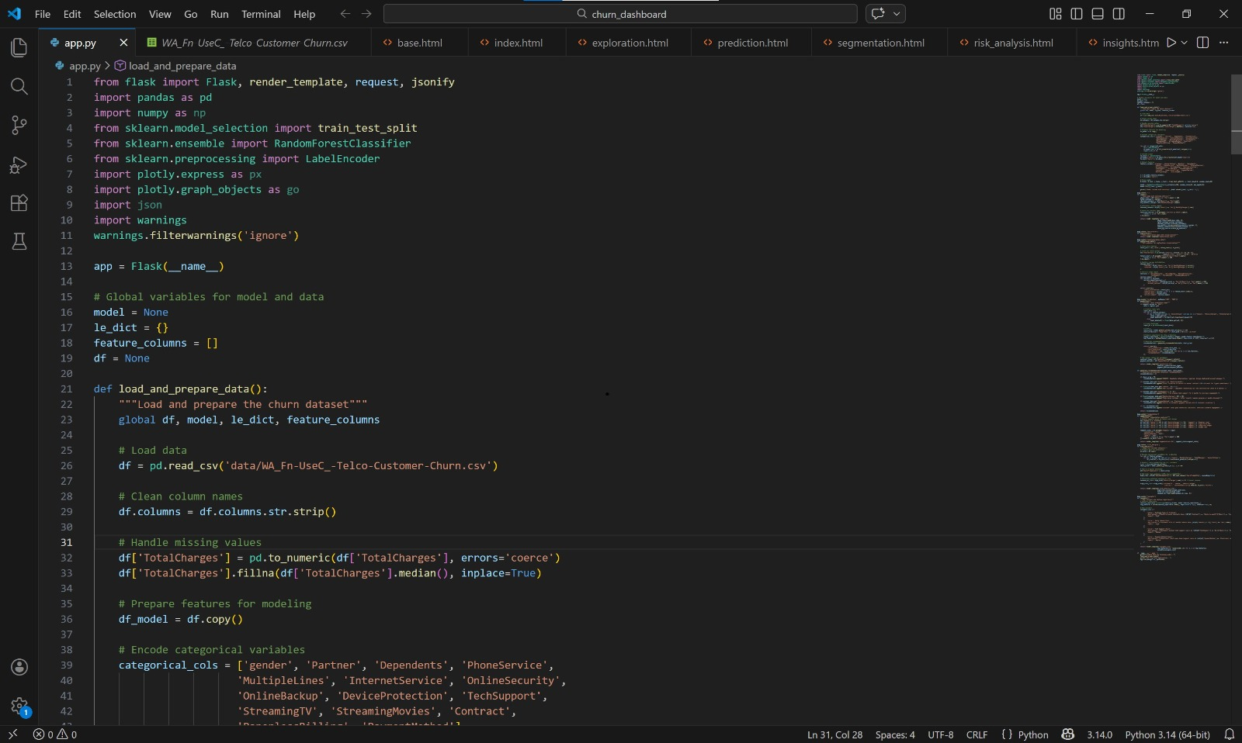
Customer churn web application home interface with dashboard and navigation options for data exploration, prediction, segmentation, risk analysis, and insights.
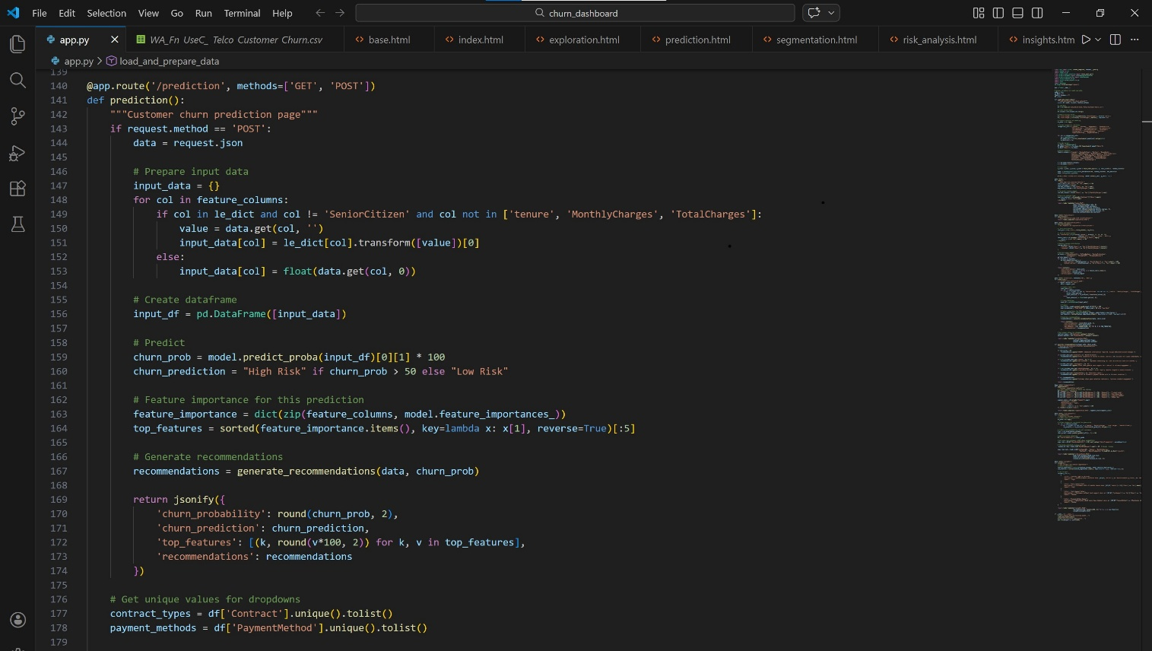
Customer churn prediction interface displaying the churn probability, risk level, and recommended retention strategies based on customer input.
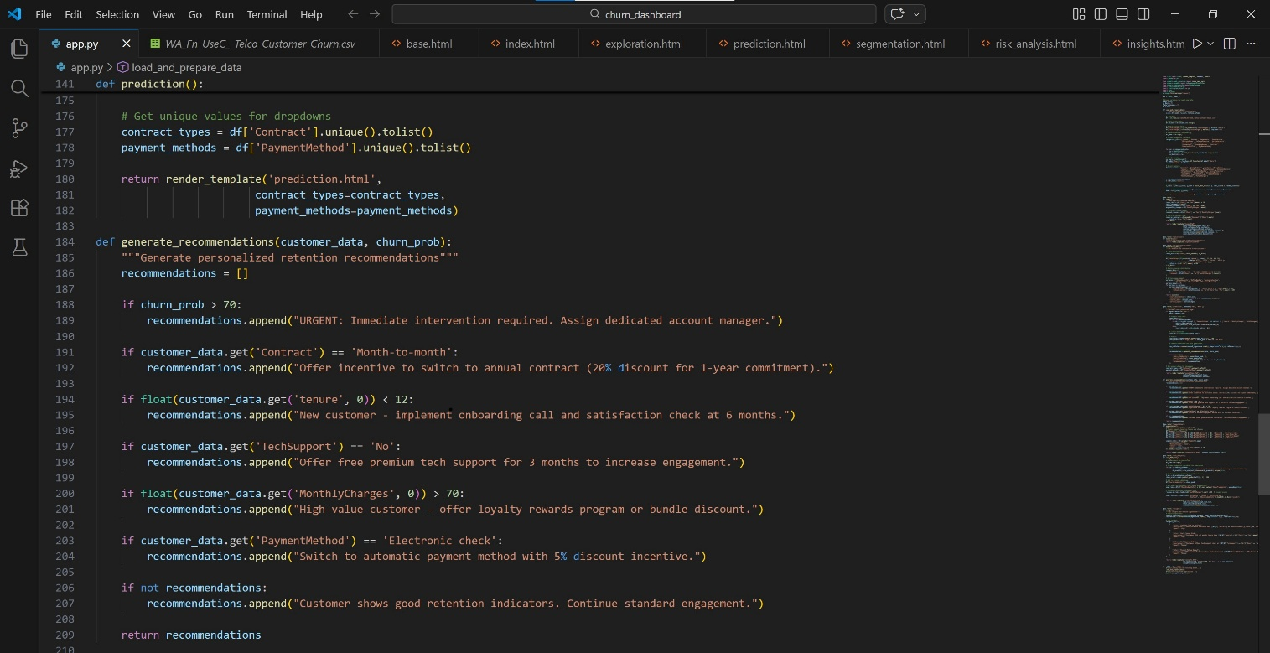
Customer churn prediction result interface showing churn probability, risk classification, and personalized recommendations for customer retention.

Customer churn web application dashboard interface displaying key metrics, visualizations, and navigation options for exploring different analysis pages.

Customer churn data exploration interface showing charts and graphs used to analyze patterns and relationships in the telecom customer dataset.

Customer churn prediction interface allowing users to enter customer details and predict churn probability using the machine learning model.

Customer segmentation interface categorizing customers into different groups based on their behavior and service usage patterns.

Customer churn risk analysis interface highlighting high-risk customers and factors that contribute to churn through analytical visualizations.

Customer churn insights interface presenting important findings and summarized insights derived from the churn analysis.

  - Challenges Faced:
During the internship project, several practical challenges were encountered. Initial data preprocessing required careful handling of missing values, inconsistent data types, and categorical variable encoding to ensure accurate analysis. Converting features such as Total Charges into proper numeric format and managing imbalanced churn classes required additional validation and preprocessing steps.
Handling multiple customer attributes while identifying the most influential churn factors required systematic exploratory analysis and feature selection. Ensuring proper data splitting and avoiding overfitting during machine learning model training was also a key challenge. Model performance needed to be carefully evaluated using appropriate metrics rather than relying solely on accuracy.
Additionally, designing a clear and informative dashboard layout that effectively communicated business insights required multiple refinements. These challenges strengthened analytical thinking, improved technical problem-solving skills, and provided practical experience in handling real-world customer data for predictive analytics.

Learning Outcome
The internship significantly enhanced my technical and analytical competence in the domain of Data Science, Machine Learning, and Business Analytics. Through hands-on training, I developed proficiency in data preprocessing, feature engineering, exploratory data analysis, and predictive modeling techniques for customer churn analysis.
Working with real-world telecom datasets strengthened my understanding of data integrity, handling missing values, encoding categorical variables, and ensuring proper data validation. The integration of Python libraries such as Pandas, Matplotlib, and Scikit-learn for analysis and modeling, along with dashboard development tools for visualization, provided comprehensive exposure to practical data science workflows.
Furthermore, the experience deepened my understanding of classification algorithms, model evaluation metrics, and performance optimization techniques. Exposure to machine learning concepts within customer analytics broadened my perspective on how predictive modeling supports customer retention strategies and revenue optimization. Overall, the internship cultivated critical thinking, problem-solving ability, technical debugging skills, and the capacity to interpret data-driven insights for effective business decision-making.

Conclusion

The internship provided a valuable academic and technical experience, effectively bridging theoretical knowledge with real-world data science implementation. The Customer Churn Analytics project demonstrated the practical application of data analysis and machine learning techniques in understanding customer behavior and predicting churn patterns.
By combining data preprocessing, exploratory analysis, predictive modeling, and interactive dashboard visualization, the project reflected an integrated and structured analytical approach. The development of the churn prediction model and dashboard strengthened my technical foundation in Data Science and Machine Learning while enhancing my understanding of data-driven business intelligence.
This internship has equipped me with the practical skills and confidence required to undertake advanced analytics projects and contribute meaningfully to customer retention strategies, business optimization, and AI-driven decision-making processes in real-world industry settings.

7. Internship Completion Certificate


Rajalakshmi Engineering College Thandalam, Chennai.

DEPARTMENT OF ARTIFICIAL INTELLIGENCE AND DATA SCIENCE

Internship Feedback Form

Student Details:
Registration Number : Student Name : Department : Artificial Intelligence and Data Science
Year / Semester : Internship Organization : Trainer Name : Internship Period : FROM : TO: Internship Duration : DAYS

Section A: Student Feedback (to College)
- Overall, how would you rate your internship experience?
  - Excellent ☐ Very Good ☐ Good ☐ Satisfactory ☐ Poor
- Did the internship help you gain useful knowledge or skills?
  - Yes ☐ Partially ☐ No
- What did you like most about your internship?

- Remarks:

Student Signature: Date:

Section B: Organization Feedback (to College)
- Student’s overall performance:
  - Excellent ☐ Very Good ☐ Good ☐ Satisfactory ☐ Poor
- Attitude, discipline, and professionalism:
  - Excellent ☐ Very Good ☐ Good ☐ Satisfactory ☐ Poor
- Contribution to assigned tasks/projects:
  - Excellent ☐ Very Good ☐ Good ☐ Satisfactory ☐ Poor
- Comments / Recommendations:

Organization Mentor/Manager Name & Designation:

Signature & Date:

